CrossWords
Monthly Newsletter of Cross Ev. Lutheran Church
6001 Main St. Rockford, MN 55373 Phone: 763-477-5981
website: www.crosslutheranwels.org email: office@crosslutheranwels.org
Pastor: Rev. Michael Barlow home: 763-477-5292 cell: 763-276-8750
email: pastor@crosslutheranwels.org
January 2017 Volume 17, Issue 1

The Books of the Bible

When we use the word canon—with one n—it means “a standard or rule,” like a measuring stick. Christians have adopted this term to designate those writings which are the standard for Christian faith and life. These writings, recognized as God’s inspired and inerrant Word, are the 66 canonical books of the Bible.
Since the Bible is God’s gift to mankind, the authority to decide which writings belong to the canon lies with God alone. The Christian church has not created the canon and decided which books belong in the Bible. Instead, Christians have only recognized that the 66 books of the Bible are God’s Word.
But what is the determining factor in recognizing canonical books? How do we know, for example, that the Old Testament book of Joshua should be included in the canon, while other ancient writings like the book of Tobit should not?
We recognize the 39 books of the Old Testament as canonical because during his earthly ministry Christ put his stamp of approval on them. At the time of Jesus, the Jewish teachers had already recognized these same 39 books as being God’s inspired Word. They grouped these 39 books into three categories: the Law of Moses, the Prophets, and the Psalms. Jesus accepted all these books, regularly spoke of them as God’s Word, and said that they could not be broken.
The 27 New Testament books were written after Jesus ascended into heaven. So how was the New Testament canon recognized and established? The church is “built on the foundation of the apostles and prophets, with Christ Jesus himself as the chief cornerstone” (Ephesians 2:20). So the writing of the apostles is important. They were eyewitnesses of the Savior’s ministry or, in the case of Paul, a man later called by Christ himself. They are reliable witnesses. But more than that, Christ sent the Holy Spirit to these men in a special way. He inspired them so that what they wrote was the Word of God, on the same level as the Old Testament Scriptures.
Finally, we also recognize the 66 books of the Bible to be canonical because of the testimony of the Holy Spirit in our hearts. God’s Word is powerful and active, living and life-giving. Through the centuries, as people have read the Scriptures, the Holy Spirit has produced in them a new spirit, attitude, and life. As we continue to read and understand the writings of the prophets and apostles, God’s Spirit also works in our hearts the conviction that what we have in these writings is the very Word of God.

© 2016 Northwestern Publishing House. All rights reserved. Scripture is taken from THE HOLY BIBLE, NEW INTERNATIONAL VERSION®.

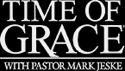

KMSP |  | Channel 9 | Sundays | 6:30 AM

Our Congregation’s Mission Statement
This statement, in a concise and novel way, summarizes our mission and purpose for existing. All other groups and activities within the congregation ought to be carrying this mission out.
Cross Ev. Lutheran Church exists to give glory to our God and Savior by
Regular worship and faithful use of the Means of Grace with
Outreach to the community, nation, and world through our prayers and offerings by
Serving our fellow Christians and community, in turn
Strengthening our faith and promoting Christian fellowship.

Please check out our congregation’s Facebook page and “like” us. Check us out every few days and “like” some of the inspirational and encouraging pictures and share announcements about events with your friends. This is one easy way to share information about our church and God’s Word with others.

News From The Church Council

Synod Convention Delegate: Our congregation is up for sending a lay delegate to the 2017 WELS Convention, to be held July 31 through Aug 3 at Luther Prep School in Watertown, WI. Any voting member of the congregation is eligible to attend,. Let the pastor know if you are interested.

Treasurer: Since the funds are available, the final debenture still owed will be paid off.

SPECIAL NOTE: A week or so before Christmas, the boiler that provides heat to the sanctuary of the church went out. To make a long story short, the necessary parts were replaced and repairs made, and we have a bill for a little over $3,455. This was an unexpected expense. If the Lord enables you and your heart moves you, we ask you, the members of Cross if you could contribute something over and above your regularly planned offerings to help offset this expense. Any such offerings are greatly appreciated.

Elections: At the annual meeting in January, the following positions will be up for election: Treasurer (Joel Schumann is the current treasurer and is eligible for another three-year term). One elder (Marty Bogart is incumbent eligible for a second three-year term) If you are asked to be on the ballot and serve if elected, please give your prayerful consent.
ANNUAL MEETING The Annual meeting of our congregation will be on Sunday, January 22 at 10:15 am. Reports on the various areas of ministry will be given and discussed. Among the items on the voters’ meeting portion of the meeting will be elections for the church council and adopting a budget for 2017. Everyone is encouraged to attend.

CHURCH UNDECORATING will be Saturday, January 7 at 10:00 am. please come help take down and put away the Christmas decorations. Many hands make short work!!

CROSS LIGHTS
Cross LIGHTS will not meet in January. The next meeting will be Tuesday, Feb 7 at 7:30 pm.
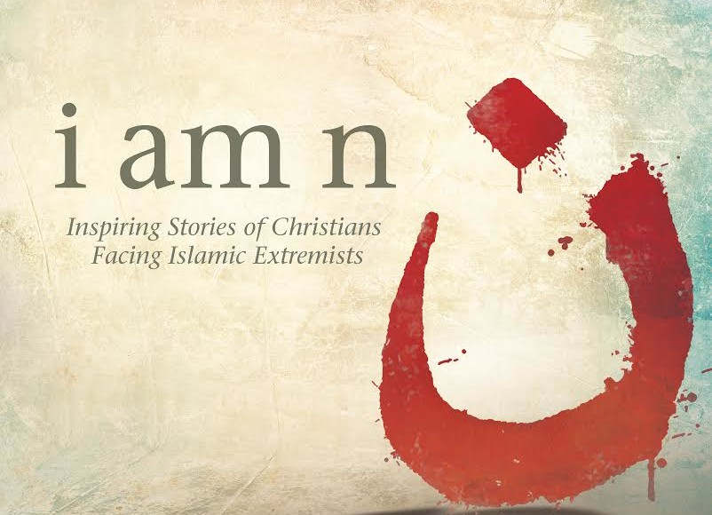

Sunday Morning Bible Study
Starts January 8, 2017, 10:15 am.
This engaging video Bible Study presents true stories of Christians facing Islamic extremists around the world. Each lesson will include a15-minute video with interviews with persecuted Christians as well as commentary and teaching . We will explore the six themes - sacrifice, courage, joy, perseverance, forgiveness and faithfulness, that will inspire you to grow deeper in your relationship with Christ and witness with boldness and joy to your friends, family and co-workers.

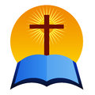
MEN’S BREAKFAST BIBLE STUDY
MBBS will meet on January 21 at 9:00 am We will study Lesson Twelve - Words From a Hard Place of our study “Hard Sayings of Jesus” The menu will include bacon, eggs & hash browns.

Join us for breakfast at the annual fund raiser for the Western Accents mission trip to Nashville this spring!
You can purchase your tickets for the Pancake Breakfast from a Western Accent member or from Mr. Baures via email or (763) 509-9378 ext. 22. Limited tickets sold at the door.

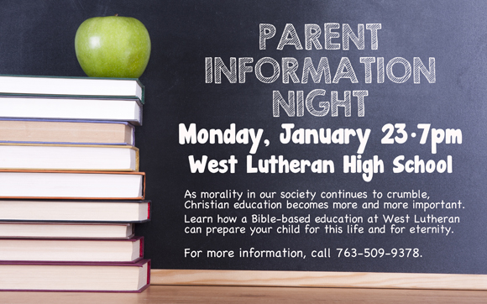

NEWS FROM THE CENTRAL AFRICA MEDICAL MISSION
Lutheran Mobile Clinic

Lutheran Mobile Clinic (CAMM)
Lilongwe Malawi
December, 2016

I lift up my eyes to the hills- where does my help come from? My help comes from the Lord, the Maker of heaven and earth.
Psalm 121: 1-2
Greetings from the warm heart of Africa!
I read somewhere that some have called Malawi the “Switzerland of Africa” due to its hilly terrain. That description makes me smile, because I appreciate hills and mountains. To me, they display a part of the majesty of God’s creation.
Malawi is indeed hilly and there are mountains on the horizon. Though it is lovely to see, it is not so lovely when you’re learning to drive a manual transmission vehicle. Never before have I spotted an incline in the road and felt butterflies about whether I’ll be able to maneuver the vehicle without rolling backwards.
Each time I start the truck for another driving session, my mind comes back to this passage. Though the hills in Lilongwe are testing my mastery (or lack thereof) of the clutch, in ancient times, the hills provided hiding places for thieves, dangerous animals and others intending harm to travelers passing by.
These days our “hills” in life take many forms. Perhaps this December you are facing a mountain of debt or a crippling financial loss. Maybe you have been ill and you feel as though getting out of bed is as difficult as scaling Kilimanjaro. Are the many miles that separate you from your loved ones crushing your cheer this Christmas?
Then remember the hill called Calvary that Jesus willingly climbed to suffer the consequences of all of our sins. When you feel that you are rolling backwards and can’t make any headway, look to our Savior who burst out from the grave and ascended into heaven. Jesus knows the peaks and valleys of our lives and He cares. He cares so much about each of us that “even the very hairs of your head are all numbered” (Matthew 10:30).
I pray you enjoy a peaceful and joyful Christmas, secure in the comfort and knowledge that the One who made the hills is also the One who will grant passage through all of our “hills”.
Your sister in Christ,

Amanda Artz, Clinic Administrator-in-Training
Lutheran Mobile Clinic

SENIOR FELLOWSHIP
Senior Fellowship will hold it’s January meeting on Thursday, January 19, starting at noon. Details will be announced in the Sunday bulletin and by email.

t

